1. **PARTS OF A COMPUTER & ASSEMBLING A COMPUTER**

**VOCABULARY**

**PARTS OF A COMPUTER**

DVD drive - unidad de dvd

fan - ventilador

hard drive disco duro

heat sink - disipador de calor

motherboard - placa base

processor (CPU) - procesador

RAM chip - RAM

sound card - tarjeta de sonido

USB port - puerto usb

**ADJECTIVES**

advanced - avanzado

basic - básico

cheap - barato

expensive - caro

heavy - pesado

large - grande

light - ligero

little - pequeño

loud - alto

narrow - estrecho

quick - rápido

quiet - callado

slow - lento

useful - útil

useless - inútil

wide - ancho

**ORDINALS**

first - primero

second - segundo

third - tercero

fourth - cuarto

fifth - quinto

sixth - sexto

seventh - séptimo

eighth- octavo

ninth - noveno

tenth - décimo

**PARTS OF A COMPUTER**

cable - cable

case - caso

clip - acortar

front panel - panel de control

power supply - fuente de alimentación

side panel - panel lateral

slot - ranura

socket - enchufe

switch - cambiar

**VERBS**

attach - adjuntar

connect - conectar

detach - despegar

disconnect - desconectar

insert - insertar

plug in - enchufar

remove - borrar

screw - atornillar

turn off - apagar

turn on - encender

unplug - desenchufar

unscrew - desatornillar

**EXTRA!**

cache - cache

desktop case - caja de escritorio

disc controller disco controlador

drive bay - compartimento de la unidad

expansion cards - expansión de tarjetas

I/O Adapter - Actualizador I/O

Network Attached Storage (NAS) - Almacenamiento en red

optical drive - unidad óptica

tower case - caja de la torre

**PRACTICE!**

1. **Match the words to the parts of the computer.**

*hard drive • motherboard • RAM chip • USB port • sound card • heat sink and fan • DVD drive • processor (CPU)*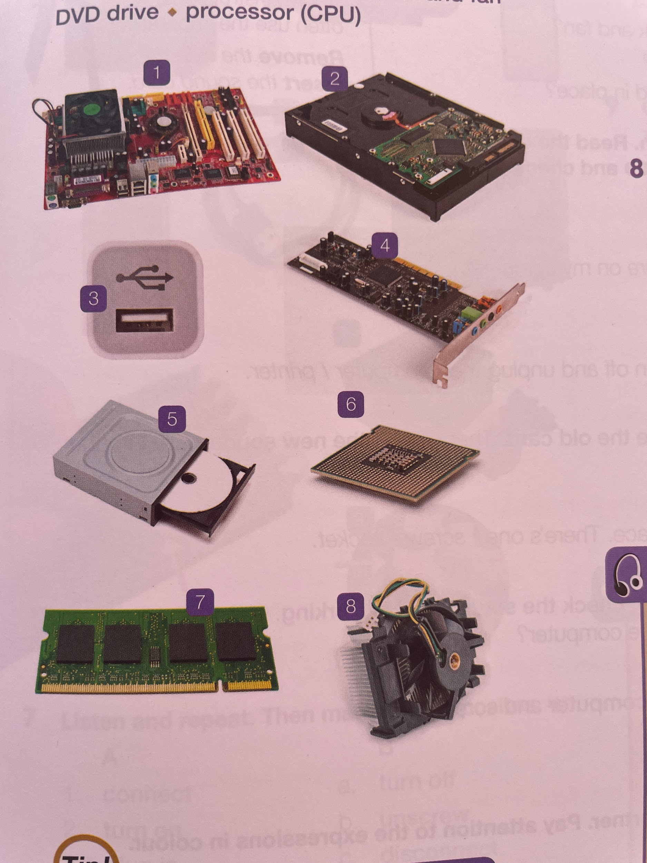

1. ___Motherboard________
2. ___Hard drive__________
3. ___USB port___________
4. ___Sound card_________
5. ___DVD drive__________
6. ___Processor CPU______
7. ___RAM chip___________
8. ___Heat sink and fan____

**2. Match the computer components in exercise 1 to the definitions below.**

1. This is the computer's brain. _____CPU______________________

2. This is the main storage space for data. _____Hard drive__________________

3. This allows the computer to have audio. _____Sound card_________________

4. This is also called a memory module. _____RAM______________________

5. This stops the processor from getting too hot. _____Fan and heat sink____________

6. This contains the main components of a computer. _____Motherboard________________

7. This reads and writes disks. _____DVD drive__________________

**3. Match the opposites.**

| **A**  1. cheap  2. heavy  3. little  4. quick  5. basic  6. quiet  7. useful  8. wide | **B**  _4__ a. slow  _5__ b. advanced  _7__ c. useless  _1__ d. expensive  _8__ e. narrow  _6__ f. loud  __2_ g. light  _3__ h. large |
| --- | --- |

**4. Copy and complete the sentences with words from Exercise 3.**

1. I haven't got enough money for this computer. It's too ____cheap__________ for me.

2. My old computer was quite loud, but this one is really ____quiet__________

3. Modern computers are quite ____light__________, not like the old heavy ones.

4. A more ____expensive__________ computer model has got better quality hardware.

5. My motherboard doesn't work! The whole PC is _____useless_________ now.

**5. Match each ordinal to the correct word.**

*third • sixth • second • tenth • first seventh • ninth • fifth • eighth*

1st ____first_______

5th ____second_______

8th ____eightth_______

2nd ___second________

6th ___sixth________

9th ___ninth________

3rd __third_________

7th __seventh_________

10th __tenth_________

**6. Match each word to the correct picture.**

*cable • clip • side panel • case • front panel power supply • socket • switch • slot*

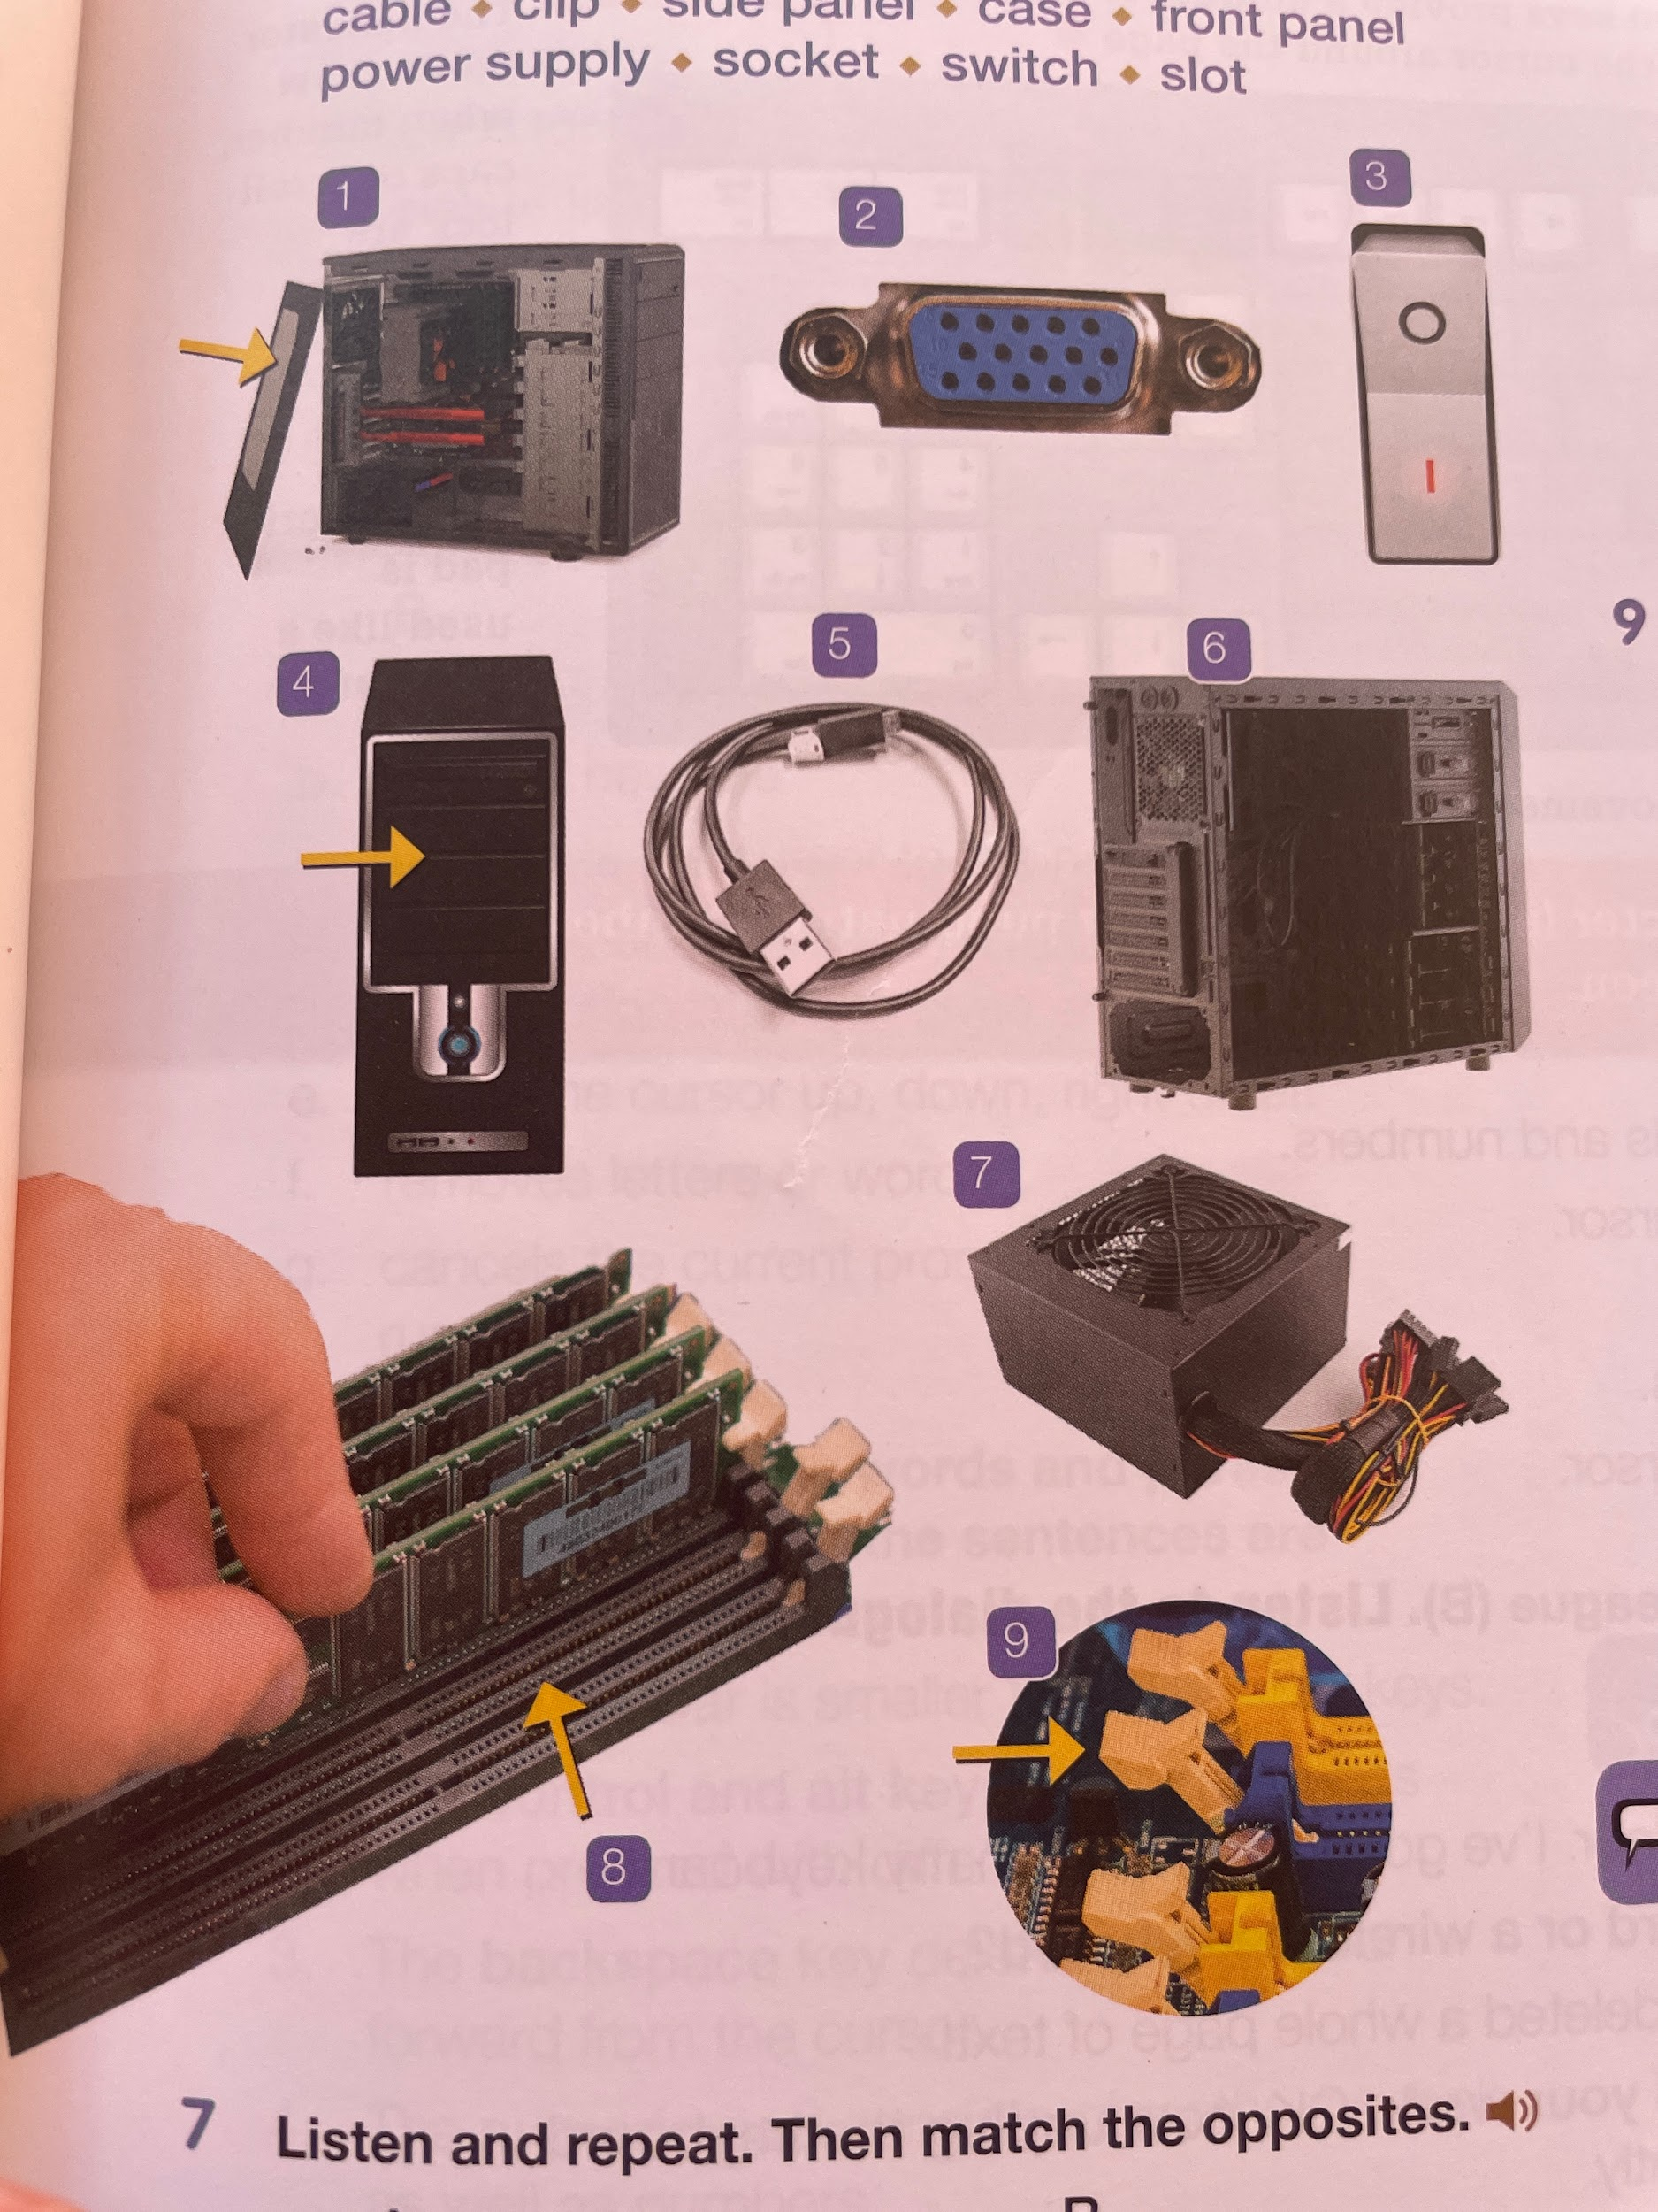

1. __side panel___________________
2. ___socket__________________
3. ___switch__________________
4. ___front panel__________________
5. ___cable__________________
6. ___case__________________
7. ___power suply__________________
8. ___slot__________________
9. ___clip__________________

**7. Match the opposites.**

| **A**  1. connect  2. turn on  3. plug in  4. screw  5. insert  6. attach | **B**  _2__ a. turn off  _4__ b. unscrew  _1__ c. disconnect  _5__ d. remove  _3__ e. unplug  _6__ f. detach |
| --- | --- |

**8. Choose the best continuation for each sentence.**

**1. Before you remove the panels,**

a. make sure you disconnect the cable.

b. connect all the cables.

**2. In order to open the door of the room,**

a. detach the card.

b. insert the card in the slot here.

**3. There's nothing to watch on TV,**

a. so l'm going to turn it on.

b. so l'm going to turn it off.

**4. Before you take the side panel off,**

a. you have to unscrew it.

b. you have to screw it on.

**5. Before you put the new sound card in,**

a. you have to attach the old sound card.

b. you have to remove the old sound card.

**6. Never touch anything inside the computer**

a. if it's unplugged!

b. if it's plugged in!

**9. Complete the sentences with the words below.**

*unscrew • switch • cable • power supply plug in • turn it off*

1. Don't forget to plug the computer into the ....power supply

2. You can connect the monitor to the computer using this ....cable

3. When you've finished using the computer, make sure you ....turn it off

4. Before you remove the motherboard, you have to .unscrew.. it.

5. ...plug in the laptop cable before you turn it on.

6. This is the main switch… to turn the computer on and off.